Installing East Asian Language Support Under Windows XP
This page outlines the steps for installing East Asian languages on a computer running Windows XP so that the user can both read and write in them. For Windows 2000 Professional and Windows Vista, please see the page on how to enable East Asian languages on Windows 2000 Professional and Windows Vista respectively, since the steps are somewhat different. Windows 95/98/Me/NT4 users have to download Asian language support and input editor files from Microsoft's Web site.
- First open the Control Panel dialog box by clicking on the Start button, and then click on Control Panel. By default the Control Panel is in the new Category View. If that is the case, click on Date, Time, Language, and Regional Options under Pick a Category. If not, you can either click on Switch to Category View to bring it up, or work in the Classic View (in that case just double click on the Regional and Language Options icon to open the Regional and Language Options dialog box; go on to section (3)).
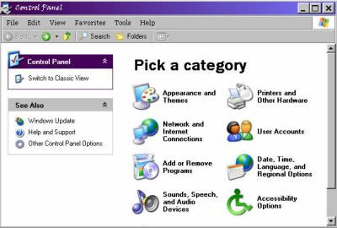
- The Date, Time, Language, and Regional Options opens. Click on Regional and Language Options under or Pick a Panel Control icon.
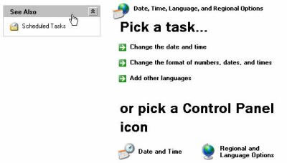
- You get the Regional and Language Options dialog box. Click on the Languages tab.
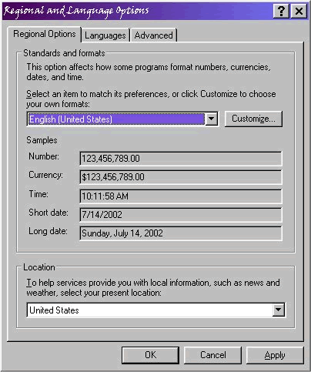
- You are now under the Languages tab for the Regional and Language Options dialog box.
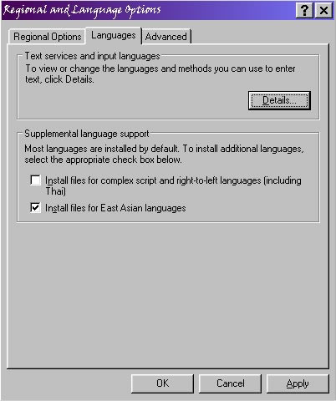
Check the box for Install East Asian Languages under Supplemental language support. Then click Apply and OK.
- Once the language files have been installed, click on the Details ... button under Text services and input languages while you are still under the Languages tab for the Regional and Language Options dialog box. You get the Text Services and Input Languages dialog box.
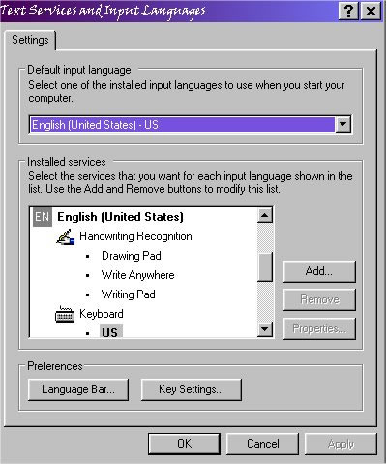
Then click on the Add.. button under Installed services.
- The next 3 sections explain how to install Microsoft Pinyin IME 3.0 for simplified Chinese. (A number of other input methods for Chinese are available.) For installing Microsoft New Phonetic IME 2002a for traditional Chinese, skip to section (11). For installing Japanese MS-IME Standard 2002 (which allows the writing of kana and kanji by romaji input), skip to section (14). I have not provided an example for installing Korean language input, but the steps should be similar to those for installing Japanese and Chinese.
- After you have clicked the Add .. button under Installed services in the Input Locales tab while you are in the Text services and input languages dialog box as outlined in section (5), you get the Add Input Language dialogue box. Choose Chinese (PRC) from the drop-down list under Input Language, check the Keyboard Layout / IME button, and then pick Chinese (Simplified) - Microsoft Pinyin IME 3.0. Then click OK.
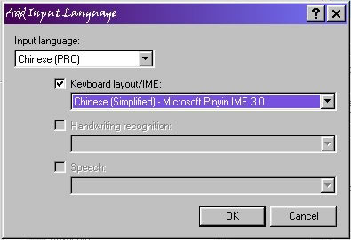
- You are now back to the Text Services and Input Languages dialog box. Note that under Chinese (PRC) /Keyboard, Chinese (Simplified) - Microsoft Pinyin IME 3.0 is now listed. Click Apply and then OK.
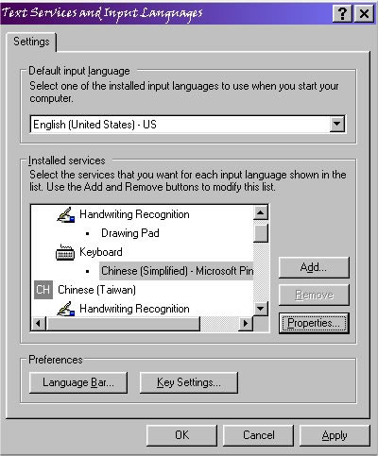
- After you have installed Chinese (Simplified) - Microsoft Pinyin IME 3.0, you may want to fine tune its properties. To do this, first select Chinese (Simplified) - Microsoft Pinyin IME 3.0 under Installed services in the Text Services and Input Languages dialog box by clicking on and highlighting it. Then click on Properties to bring up the Properties dialog box for Microsoft Pinyin 3.0.
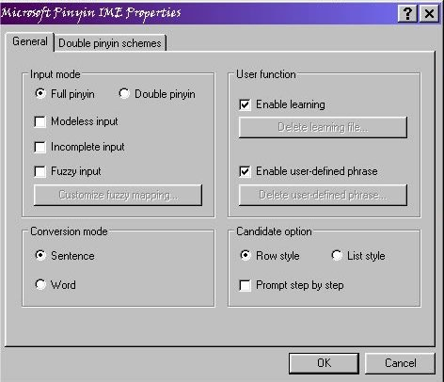
Experienced users will want to pick and choose their options. For new users, it is strongly recommended that the default options be left in place.
- Microsoft Pinyin 3.0 allows toggling between traditional and simplified Chinese input, and so if you want to be able to write both traditional and simplified characters and you are comfortable with Pinyin romanization, you may not need to install a traditional Chinese input option additionally. (Skip this section if you don't want or need to enable toggling between simplified and traditional characters.)
After you finished installing Chinese (Simplified) - Microsoft Pinyin IME 3.0, you should see a floating language bar near the top of the screen.
If instead of the floating language bar, you see a language button on the taskbar on the bottom of the screen, click on the button to bring up a list of languages installed, and then click on Show the Language bar to bring it up.
Once the language bar is up, click on it to bring up a list of languages installed, and select Simplified Chinese (PRC) by clicking on it. The Chinese lanuage bar comes up.
By default the toggle button for switching between simplified and traditional does not appear on the language bar for Simplified Chinese in Windows XP (unlike the menu bar for MS-Pinyin98 under Windows 2000 Professional). To enable it, click on the select button (the bottom part of at the right side of the language bar) for additional user selectable settings.
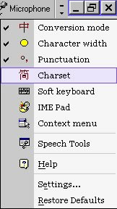
Move the mouse to the option Charset to highlight it, and then click to select it. Now the option menu contains a button for toggling between simplified and traditional characters.
- This and the following 3 sections explain how to install Microsoft New Phonetic IME 2002a for traditional Chinese. After you have clicked on the Add .. button under Installed services in the Input Locales tab while you are in the Text services and input languages dialog box as outlined in section (5), you get the Add Input Language dialogue box. Choose Chinese (Taiwan) from the drop-down list under Input Language, check the Keyboard Layout / IME button, and then pick Microsoft New Phonetic IME 2002a. Then click OK.
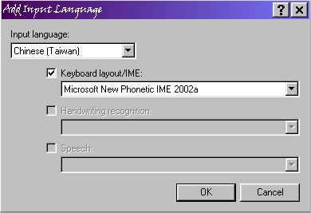
- You are now back to the Text Services and Input Languages dialog box. Note that under Chinese (Taiwan) /Keyboard, Microsoft New Phonetic IME 2002a is now listed. Click Apply and then OK.
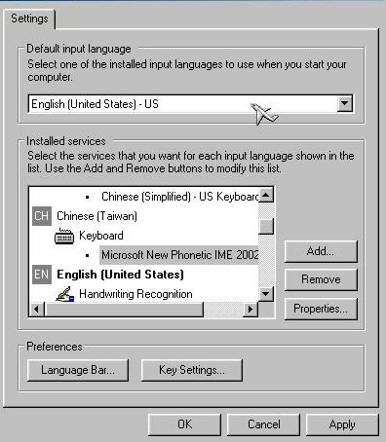
- After you have installed Chinese (Taiwan) /Keyboard, Microsoft New Phonetic IME 2002a, you may want to fine tune its properties. To do this, first select Chinese (Taiwan) /Keyboard, Microsoft New Phonetic IME 2002a under Installed services in the Text Services and Input Languages dialog box by clicking on and highlighting it. Then click on Properties to bring up the Properties dialog box for Microsoft New Phonetic IME 2002a.
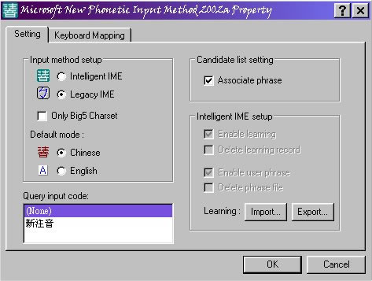
Experienced users will want to pick and choose their options. For new users, it is strongly recommended that the default options be left in place.
- In my case because I am familiar with Pinyin romanization but not with other Chinese language input methods, I clicked the radio button for Legacy IME under the Settings tab of the Properties dialog box for Microsoft New Phonetic IME 2002a, and the HanYu Pinyin radio button under the Keyboard Mapping tab.
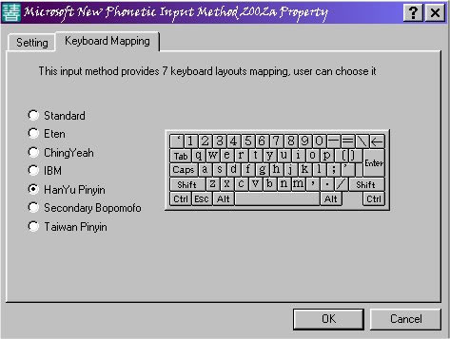
- This and the following 2 sections explain how to install Japanese MS-IME Standard 2002. After you have clicked the Add .. button under Installed services in the Input Locales tab while you are in the Text services and input languages dialog box as outlined in section (5), you get the Add Input Language dialogue box. Choose Japanese from the drop-down list under Input Language, check the Keyboard Layout / IME button, and then pick Microsoft IME Standard 2002 ver 8.1. Then click OK.
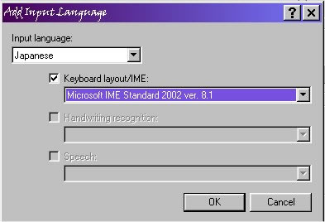
- You are now back to the Text Services and Input Languages dialog box. Note that under Japanese /Keyboard, Microsoft IME Standard 2002 ver 8.1 is now listed. Click Apply and then OK.
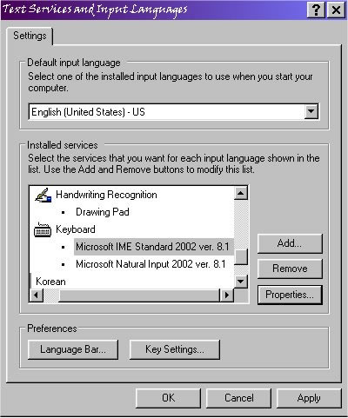
- After you have installed Microsoft IME Standard 2002 ver 8.1 for Japanese, you may want to fine tune its properties. To do this, first select Microsoft IME Standard 2002 ver 8.1 under Installed services in the Text Services and Input Languages dialog box by clicking on and highlighting it. Then click on Properties to bring up the Properties dialog box for Microsoft IME Standard 2002.
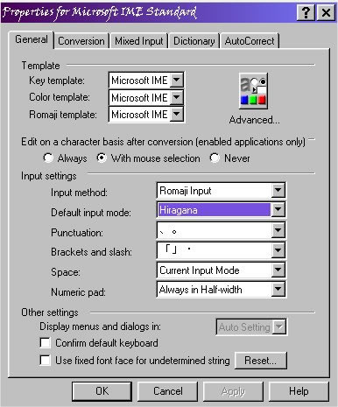
Experienced users will want to pick and choose their options. For new users, it is strongly recommended that the default options be left in place.
There appears to be a bug in the English Windows version of Microsoft IME Standard 2002. Even though Hiragana is selected as the Default input mode, the IME always starts in Direct input mode. You have to manually change to Hiragana mode.
- Voilà! You are now ready to both read and write Chinese and/or Japanese in your documents. You will see near the upper right hand corner of the Windows desktop the Language bar button , which allows users to change the input language in an application by left clicking on it to bring up the language choices available and then selecting and clicking the desired language. Note that within the same document you can change the input language by using the Language bar. You can produce a document with a mixture of different languages.
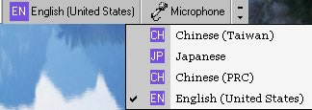
- New users may want to take a look at the pages for writing Chinese and Japanese to get started quickly with working with Chinese and/or Japanese in their documents. Please see also the overview on reading and writing e-mail in Chinese and Japanese.

