Go to Control Panel -> Regional Options
Click Languages tab
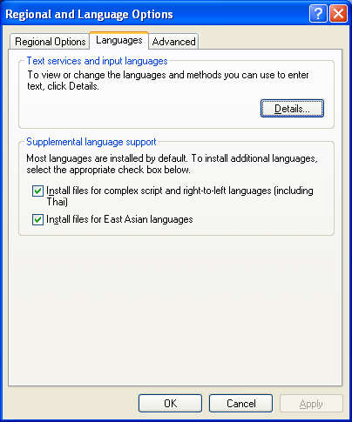

Click Details button on Languages tab
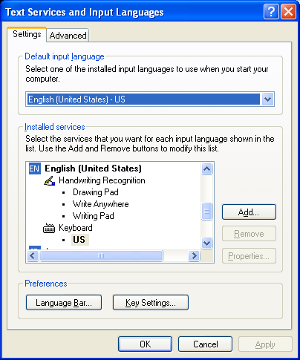
Click Add button
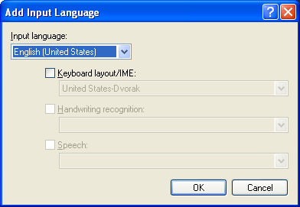

Select Chinese(PRC) for the Input language,
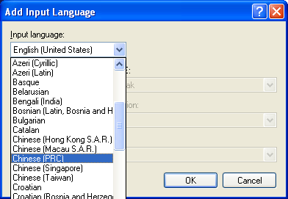

Select Chinese(Simplified) – Microsoft Pinyin IME 3.0 for keyboard layout/IME
Then click OK
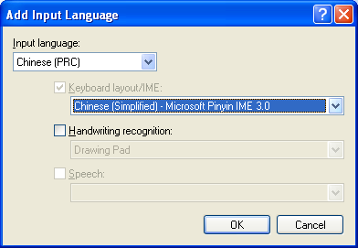

Highlight Chines(Simplied) – Microsoft Pinyin 3.0 then click Properties to set the correct property, click OK and Apply to close all the windows.
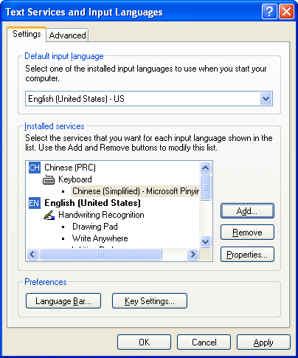
Properties setting recommand:
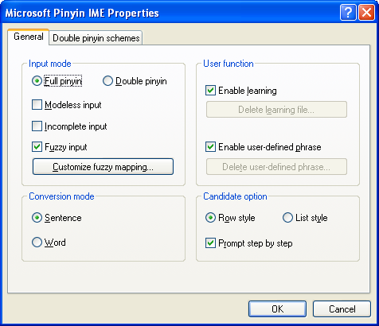
Chinese (PRC) is ready for you to input for Chinese characters:
You can left click on “EN” then select “Show the language bar”, you can move laguage bar to whereever you prefer to.
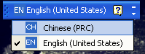

Select CH Chinese (PRC)， note: you need to open an editor to make the selection work.
You can click the rightmost triangle to toggle the tool set
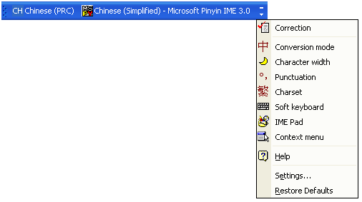

Example: select Conversion mode and Charset then the Charset will be placed to the language bar, click on Charset then it will show tranditional or simplifies charset. You need to set Conversion mode to Chinese before you can toggle between tranditional or simplified char set.
